**Keyboard History**

1. The Beginning

When we think about typewriters, in case anyone of us still does, we think about this big old dusty machine with a paper in front. 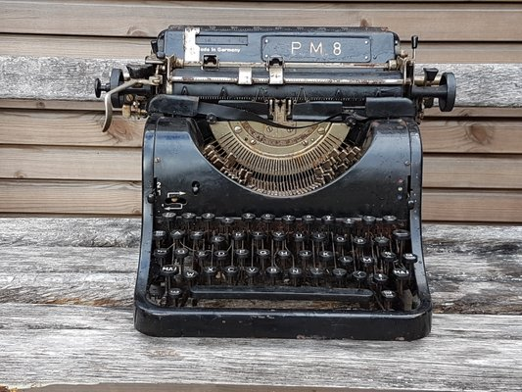

But in the behinning, they were far different.

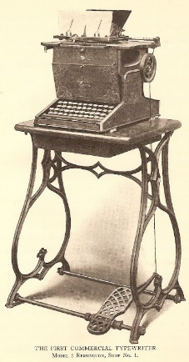

This one is one of the first prototypes made in 1867. It’s mechanism was kinda similar to a sewing machine, you just press the pedal and start working with it.

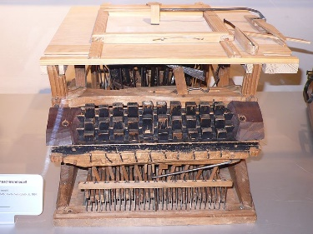

And this one is a pretty rare one, it was made in 1861, even before than the pedal one. So even at that time, there was an idea or even a design that looked pretty similar to what we will end up having.

These designs were the top notch of the market, and around 1920-1930, they developed the beautiful piece of art that we all know in our days.

It was the design used until IBM came to the market in 1961 and launched it’s own product

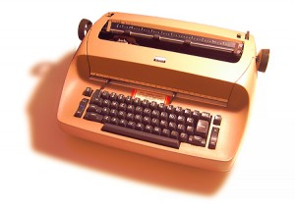

This was the Selectric Typewriter, which no longed needed type-bars that struck the page and it used instead typeballs which printed the letters. This was huge, because it means that the typewriter will no longer jam if you were typing too fast, which obviously increased the writing speed and efficiency.

Also changing the font of the letter and the color was rather easy

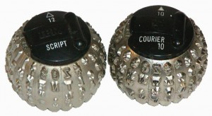

The typewriter was heavy and clunky, but you only needed to change this little balls in order to change whatever you needed in your font or color.

Also, it was produced until 1980, which leads us to our next point in our presentation. The actual keyboard.